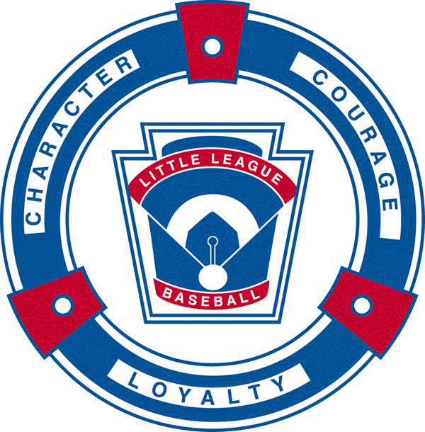 | Charlevoix Little League  Sponsorship Form | 
Yes, I wish to support Charlevoix Little League and contribute to the development of the youth of Charlevoix.

Enclosed is my payment for the sponsorship level checked below:

√ | Sponsorship  Level | Donation Amount | Sponsorship package details
 | Business
 | Hall of Fame Sponsor | $500  per season | - 5 ft. x 8 ft. banner located in the outfield on the Charlevoix Little League Field  - Official CLL Sponsor status with the right to use Charlevoix Little League logo and “Sponsor of Charlevoix Little League” in advertising for 1 year  - Premier listing with the sponsor’s logo on CLL website under Hall of Fame Sponsors  - Business name printed on opening day handout  - Sponsor recognition over p.a. during game.  - Thank you letter from Charlevoix Little League
 | Grand Slam Sponsor | $300 | - 3 ft. x 6 ft. banner located in the outfield of one of the baseball or softball fields located on Carpenter Street  - Official CLL Sponsor status with the right to use Charlevoix Little League logo and “Sponsor of Charlevoix Little League” in advertising for 1 year  - Listing on CLL website under Grand Slam Sponsors  - Business name printed on opening day handout  - Sponsor recognition over p.a. during game.  - Thank you letter from Charlevoix Little League
 | Individual/Family
 | All-Star Sponsor | $300 | - 3 ft. x 6 ft. banner located in the outfield of one of the baseball or softball fields located on Carpenter Street  - Listing on CLL website under Individual/Family Sponsors  - Thank you letter from Charlevoix Little League
 | Gold Glove Sponsor | $150 | - Listing on CLL website under Individual/Family Sponsors  - Thank you letter from Charlevoix Little League
 | Home Run Sponsor | $50 | - Listing on CLL website under Individual/Family Sponsors  - Thank you letter from Charlevoix Little League

Contact Name |  | Contact Email
Business Name |  |  | Phone
Business Address (for billing & mail)
Business Address (for billing & mail) |  |  | Postal Code
Field Preference for Banner (please circle) | SOFTBALL BASEBALL

Sign and Sponsors: Please email “digital” artwork and/or company logo to: sponsorchlxlittleleague@gmail.com

All Sponsors:

Please make check payable to “Charlevoix Little League” and mail to:
Charlevoix Little League, P.O. Box 587, Charlevoix, MI 49720

If you would like additional information, please contact a board member of Charlevoix Little League.

